Parishes of the Holy Name of Jesus and St Peter’s

R.C. Diocese of Shrewsbury a registered charity 234025

60 Beresford Road, Oxton, Prenton CH43 2JD Tel: 0151-232-4130. Mob 07903645447
Parish Priest: Fr. John Hovington office@holynamechurch.co.uk
Deacon: Revd. Les Arch les.arch@btinternet.com`
website : www.holynamestpeters.co.uk
5th July 2020 14th Sunday of the Year
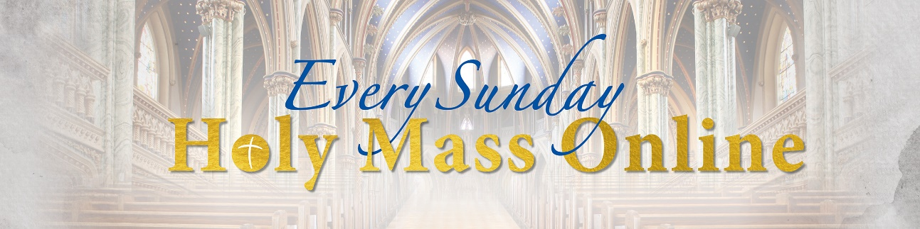

There is the opportunity for live streaming of Masses at a number of sites including:
Redemptorist Father Fr Denis McBride https://www.rpbooks.co.uk/holy-mass-online
St Anthony’s Wythenshawe website www.wythcc.co.uk
St Michael and All Angels and St Joseph’s. Birkenhead www.stmaaa.co.uk
https://www.albanstephen.org/albanstephens/wp-content/uploads/2020/03/200318-Mass-streaming-and-useful-websites.pdf
If you click on the above links you will be led directly to the sites
*************************************

I am Proposing to say public Sunday Mass next weekend. Obviously, we will have to obey the rules of social distancing and the special rules for the reception of communion which will be given only in the hand and will not be accompanied with any dialogue (i.e. Body of Christ and the response Amen). In other words, it will be offered and received in silence.
One thing that may be important to many of you is that the obligation for Sunday attendance remains suspended and consequently you are at no fault if you don’t go to Mass.

Masses:
Sunday 12th July | 9.30am | St Peter’s |  | Parishioners
 | 11.30am | Holy Name |  | Parishioners

*************************************
Your prayers Please pray for those who are celebrating significant anniversaries at this time of year and those who are sick: Paola Fregona, Kevin Nolan, Daniel Dobbs, Margaret Hawes, Maurice Cranney, Ron and Anja Welsh-Smyth, Connor O’Mahoney, Joan Smith, Val Lees, and for Paul McAleese, who is still very poorly.
*************************************
Website As our parish website is not operational at the moment, Parish news can be viewed via: https:www.stpeters-noctorum.wirral.sch.uk then click on Church News, or search ‘St Peter’s Noctorum’ on Facebook or if you give me your email address or one that you can access I can send you copies of it and thoughts for the day during the week and at the weekend.
*************************************
Giving by Standing Order If you wish to set up a Standing Order, either permanently, or in order to continue to make your regular Offertory giving to the Parish, during the period when Mass is not being celebrated in public, please use this address to make your payment just click on it: https://investmycommunity.com/not-logged-donator/page/holynameofjesusoxtondioceseofshrewsbury2164 If you have any difficulty contact: mike.russell@dioceseofshrewsbury.org

*************************************
Food Bank Wirral Foodbank is still operating and welcomes donations of both food and cash to help it continue to meet the needs of the most vulnerable in our society. Please visit the website www.wirralfoodbankextra.co.uk for all information about how to seek help, how to donate food, and how to give much needed funds. Urgently needed items include: tinned meat, tinned vegetables, tinned fruit, custard, and tinned fish. We have plenty of beans thank you.
************************************

The Uniforms they wear

The humble, the gentle, the merciful, the just.
the devout, and loyal souls all belong to one religion;
and when death takes away the masks,
they will recognise each other,
even though the different uniforms they wear here
makes them look like strangers.
(William Penn 1644 – 1718)

The difference

For Methodists,
what is allowed is allowed,
and what is not allowed is not allowed.
For Anglicans,
what is allowed is allowed,
and what is not allowed is allowed.
For Roman Catholics,
what is not allowed is not allowed,
and what is allowed is also not allowed.
(Anon)

