 | RA 056 Unvaccinated visitors v1 Nov 2021 | RISK ASSESSMENT  RECORDING FORM

Location or School  Address: St Peter’s Catholic Primary School | Date assessment  Undertaken 25.11.2021 | Assessment undertaken  by : Jeanne Fairbrother & Sarah Parry
Activity or  situation Unvaccinated visitor to school | Review  date: Weekly review | Signature: SJParry

Background information

Whilst nearly all of our staff are vaccinated against Covid 19 we respect the choice of the individual and acknowledge that there may be visitors to school who have decided not to be vaccinated. There has been an increase in cases of the virus in our area and we will continue to take all precautions and preventative measures that we can.

We also acknowledge that we cannot ask a visitor to provide proof of vaccination so implementation of all measures will be dependent upon transparency.

The Legislation
The Health & Safety at Work Act 1974
The Management of Health & Safety at Work Regulations 1999

1) Hazard / Activity | 2) Who can be harmed and how? | 3) What controls exist to reduce the risk?  Have you followed the hierarchy of controls (eliminate, substitute etc) | Risk Score  Consequence  X Likelihood | 4) Any further action.  This should be included in the action plan (5)
Unvaccinated visitor in school | Staff, pupils, other visitors and contractors | - Question – can the meting be held remotely?  - Visitor not to come to school if exhibiting any of the signs of COVID or is unwell  - Visitor to take an LFT test on the day of the visit and advise school of the result.  - Visitor will always wear a face-covering  - Visitors to attend school at quieter times eg before or after school.  - Meetings held outdoors  - Visitors will employ good hand and respiratory hygiene and sanitise prior to entry and during their visit  - Visitor to always maintain stringent 2 m social distancing  - Make pupils and staff aware to be particularly stringent with social distancing measures around the visitor  - Minimise the number of people in contact with the visitor  - Contacts will wear a face covering, sanitise and keep 2 m social distance as much as possible.  - The meeting room will be well-ventilated  - Adjust room layout to maintain social distancing  - The need for the visitor to move around the school is reduced as far as possible to limit opportunities for potential coronavirus transmission.  - Avoid moving around school at break and change of lessons.  - Clean the area used by wiping down with wipes and cleaning frequently touched points after use. | 2X2=4

Risk Rating | Action Required
17 - 25 | Unacceptable – stop activity and make immediate improvements
10 - 16 | Urgent action – take immediate action and stop activity, if necessary, maintain existing controls vigorously
5 - 9 | Action – Improve within specific timescales
3 - 4 | Monitor – but look to improve at review or if there is a significant change
1 - 2 | Acceptable – no further action but ensure controls are maintained & reviewed
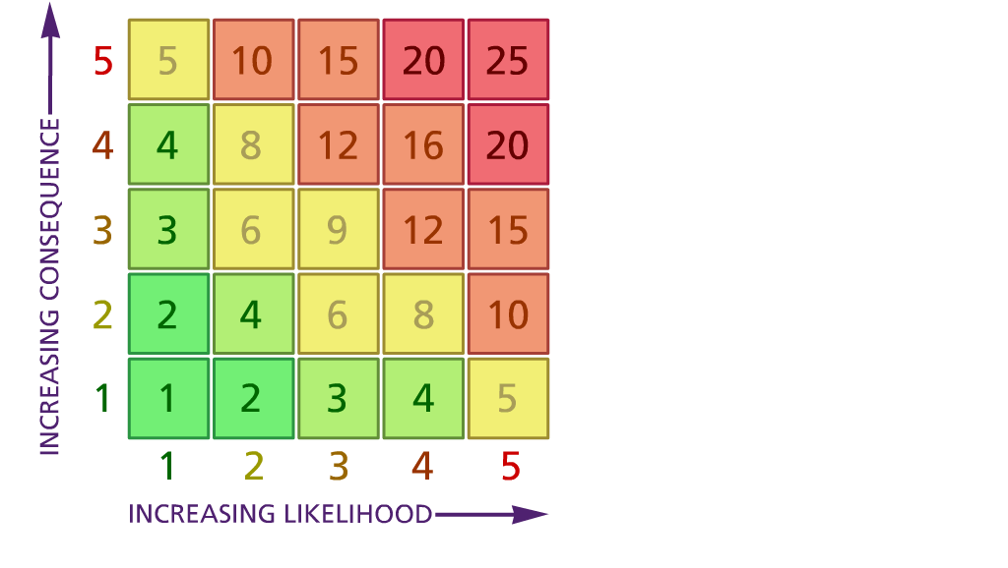

(1) List hazards something with the potential to cause harm here
(2) List groups of people who are especially at risk from the significant hazards which you have identified
- List existing controls here or note where the information may be found. Then try to quantify the level of risk the likelihood of harm arising that remains when the existing controls are in place based on the number of persons affected, how often they are exposed to the hazard and the severity of any consequence. Use this column to list the controls that you might take and develop all or some of that list into a workable action plan. Have regard for the level of risk, the cost of any action and the benefit you expect to gain. Agree the action plan with your team leader and make a note of it overleaf. If it is agreed that no further action is to be taken this too should be noted.
Likelihood: Consequence:

5 – Very likely 5 – Catastrophic

4 – Likely 4 – Major
3 – Fairly likely 3 – Moderate

2 – Unlikely 2 – Minor

