**Parishes of the Holy Name of Jesus and St Peter’s**

R.C. Diocese of Shrewsbury a registered charity 234025

# 60 Beresford Road, Oxton, Prenton CH43 2JD Tel: 0151-232-4130. Mob 07903645447

**Parish Priest: Fr. John Hovington** [**office@holynamechurch.co.uk**](mailto:office@holynamechurch.co.uk)

**Deacon: Revd. Les Arch** [**les.arch@btinternet.com`**](mailto:les.arch@btinternet.com%60)

**website :** [**www.holynamestpeters.co.uk**](http://www.holynamestpeters.co.uk)

**4th October 2020 27th Sunday of the Year**

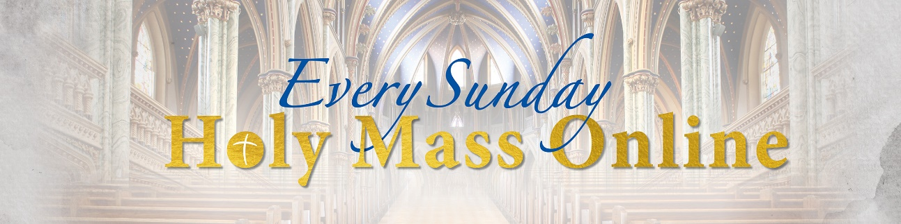

*One thing that may be important to many of you is that* ***the obligation for Sunday attendance remains suspended and consequently you are at no fault if you don’t go to Mass.***

**Masses:**

|  |  |  |  |  |
| --- | --- | --- | --- | --- |
| **Sunday 4th Oct** | **No Mass** | **St Peter’s** |  |  |
|  | **No Mass** | **Holy Name** |  |  |

\*\*\*\*\*\*\*\*\*\*\*\*\*\*\*\*\*\*\*\*\*\*\*\*\*\*\*\*\*\*\*\*\*\*\**\**\*

*I caught an article about Steph McGovern’s new programme that she is doing after leaving the BBC Breakfast programme and having her first child. Apparently, while interviewing Chris Kamara about Black Awareness Month and who, like Steph, Chris grew up in Middlesborough, she broke down in tears and they had to quickly go to an advert break. The reason was the racism she heard Chris speak about in his up bringing in his and her home town. It made me think again about the about the overwhelming white upbringing that I like many of you went through when we were young. We may have been aware of the black Ghettoes of Moss Side and Toxteth in the heart of our cities but that’s what they were, Ghettoes!*

*Thankfully, I have experienced great awakenings in the more recent years but I am very aware that, as a society, we need a long, long way to go. I am very conscious that our Church is still a very white place and we must always question ourselves as to how welcoming or unwelcoming we can be. It sickens me when I hear politicians and many ordinary people speak in unwelcoming terms about people of black, Asian and mixed-race background. That is why I welcome this month being given over to Black Awareness Month. There are many programmes and articles coming out to speak and educate us as to the great heritage and contributions that have been made by black people in our country. Let us do all we can to educate ourselves as best we can and hopefully we can eradicate the kind of stories that Chris Kamara was sharing of the prejudice and discrimination he went under as a Child and in later years.*

*Black awareness Month is on for the whole of October. Let us hope it stays in our minds and hearts beyond that time.*

**\*\*\*\*\*\*\*\*\*\*\*\*\*\*\*\*\*\*\*\*\*\*\*\*\*\*\*\*\*\*\*\*\*\*\*\*\***

**Your prayers** Please pray for those who *are celebrating significant anniversaries at this time of year* and those who are sick: Paola Fregona, Kevin Nolan, Daniel Dobbs, Margaret Hawes, Maurice Cranney, Ron and Anja Welsh-Smyth,Connor O’Mahoney, Joan Smith, and Jenny Fogg.

**\*\*\*\*\*\*\*\*\*\*\*\*\*\*\*\*\*\*\*\*\*\*\*\*\*\*\*\*\*\*\*\*\*\*\*\*\***

**Giving by Standing Order** If you wish to set up a Standing Order either permanently or in order to continue to make your regular Offertory giving to the Parish during the period when Mass is not being celebrated in public, **please send an email to Mike Russell (from the Diocesan Planned Giving & Gift Aid Service) including your name, phone number and name of the Parish. Mike’s email address is :** [**mike.russell@dioceseofshrewsbury.org**](mailto:mike.russell@dioceseofshrewsbury.org)

**\*\*\*\*\*\*\*\*\*\*\*\*\*\*\*\*\*\*\*\*\*\*\*\*\*\*\*\*\*\*\*\*\*\*\***

[Is Diversity A Virtue?](https://allpoetry.com/poem/15462417-Is-Diversity-A-Virtue--by-David-Welch)

It seems a common point of view  
that ‘diversity’ is a virtue,  
is this a truth that should be sun,  
or just a line we feed the young?  
  
Is diversity excellence?  
No, it’s a description of difference,  
there’s no moral value in that,  
nothing to make it good or bad.  
  
I think the real problem begins  
when ‘diversity is tied to skin,  
skin does not determine your mind,  
no value in it will you find.  
  
But they claim it’s ‘identity,’  
which seems very racist to me,  
and by insisting on this lie,  
folks judge by skin, not what’s inside.  
  
Which makes us cast suspicious flares,  
and burdens us with endless cares.  
Did we speak wrong? Did we offend?  
We’re so bound up we can’t be friends.  
  
All these results, so damn perverse,  
from a shallow reading of ‘diverse.’  
I think it is a better call  
to just judge the individual.  
  
But moving past a person’s hide,  
to where out cultures do abide,  
is diversity good for us?  
I think that’s a mixed bag because

All cultures out there aren’t the same,  
some function well, some are insane.

from the former we often learn,  
the later make us crash and burn.  
  
But point that out and some get mad,  
don’t want those cultures to ‘feel bad,’  
then they denigrate those that work,  
let the failed ideas drive things berserk.  
  
They think failed cultures are ‘oppressed,’  
and like to blame those that work best,  
so that we cannot appreciate  
good ideas we should assimilate.  
  
For cultures and diversity,  
it’s only virtue when we judge free.  
but this ties to another thing:  
Diversity of our thinking.  
  
Our ideas and their differences,  
can gives us all more tools, not less.  
Unique approaches, philosophies,  
can fill in where we cannot see.  
  
New ideas to which we can appeal  
to solve the challenge of the real,  
but *this* diversity they *hate*,  
they call it ‘fascist’ and berate  
  
any who will not board their boat,  
and sail upon the ship of ‘woke.’  
The one diversity that’s fine  
they curse as hateful and malign.  
  
Yet still it’s important to us,  
and should be seen as virtuous,  
the diversity that should be taught  
is free diversity of *thought.*